Project Design Phase
Problem – Solution Fit Template

Date | 27 February 2026
Team ID | LTVIP2026TMIDS41352
Project Name | ShopEZ:One-Stop Shop for Online Purchases
Maximum Marks | 2 Marks

Problem – Solution Fit Template:

1. Identified Customer Problem
Busy professionals and online shoppers struggle with:
- Time-consuming product searches
- Cluttered and confusing interfaces
- Complicated checkout processes
- Lack of personalized recommendations
- Limited seller-side management tools
- Concerns about payment security
These challenges lead to frustration, cart abandonment, and reduced trust in online shopping platforms.

2. Target Customer Segment
- Working professionals with limited time
- Online shoppers looking for convenience
- Fashion and lifestyle buyers
- Small and medium sellers managing inventory
- First-time online buyers concerned about security

3. Existing Behavior Pattern
Customers typically:
- Visit multiple websites before making a purchase
- Compare prices manually
- Abandon carts due to lengthy checkout
- Avoid platforms that feel untrustworthy
- Prefer quick, simple, and secure solutions
Sellers:
- Struggle with manual order tracking
- Lack access to proper sales analytics
- Depend on multiple tools to manage inventory

4. Proposed Solution – ShopEZ
ShopEZ addresses these problems by providing:
- Smart product filtering and easy navigation
- Clean and responsive user interface
- Seamless checkout process
- Secure authentication and payment handling
- Seller dashboard with order tracking and analytics
- Personalized product recommendations
Template:
Customer Problem | ShopEZ Solution | Why It Works
Too many product options | Smart filtering & categorized listings | Reduces decision fatigue
Limited time | Fast and seamless checkout | Saves time
Security concerns | JWT authentication & secure transactions | Builds trust
Cart abandonment | Simplified checkout flow | Reduces friction
Seller management issues | Dedicated seller dashboard | Improves efficiency
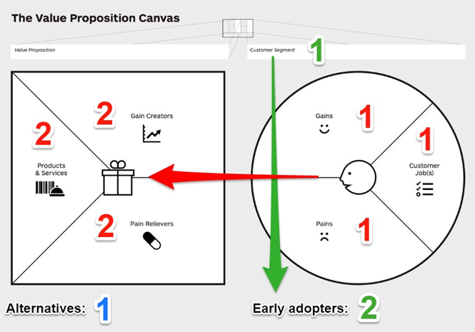
References:
- Idea Hackers Network.
Problem–Solution Fit Canvas.
Available at: https://www.ideahackers.network/problem-solution-fit-canvas/
Accessed for understanding the structure of problem–solution mapping and customer-behavior alignment.
- Epicantus (Medium).
Problem–Solution Fit Canvas.
Available at: https://medium.com/@epicantus/problem-solution-fit-canvas-aa3dd59cb4fe
Referenced for defining customer problems, existing alternatives, and validation metrics.

